NbSi thin film bolometers
on Silicon Nitride Membranes Performances :
Application to the Olimpo Experiment

Ph.Camus, 18th July, 2003

CRTBT - CNRS ( Grenoble )

Introduction 2
Detectors arrays 2
Distance center-to-center 3
Background estimation 5
Silicon Nitride Membranes Conductivity 7
NbSi thin film optimization 9
Bolometer performances estimation 11
Electrical NEP estimation 11
Thermal inertia breakdown 11
Conclusions 13
References 13

Introduction

Olimpo uses a 2.60 m telescope which gives a diffraction limited resolution at 2.0 mm wavelength ( 3 arcmin ). The focal plane is about 50 mm ( estimation ) and covers a 30 arcmin field-of-view on the sky [1].

Current process used at CRTBT/CSNSM is restricted to 2" standard silicon wafers. The useful area for the detectors is limited to a 26 mm square surface due to the space required for the pixel connections ( see Figure 2 ).

The detector performances are driven by the bolometer thermal conductance. At 300mK, full silicon membranes of 100 nm thickness have a typical thermal conductance of 1-3 nW/K leading to bolometers adapted for a rather high background operation ( ~100 pW ) and NEP ~2-5.10⁻¹⁶ W/Hz^{1/2}.

We examine the adaptation of the current detector fabrication to this application.

Detectors arrays

Four frequency channels are used in Olimpo. Each channel uses bolometers matrix at 300 mK. The 3 arcmin resolution is achieved with 19 pixels in the 2.0 mm channel. The higher frequencies are mapped with 37 pixels matrix for the same field-of-view.

CHANNEL | Center wavelength  (mm) | Center frequency  (GHz) | Number of pixels
I | 2.0 | 150 | 19 | SZ signal, diffraction limited resolution
II | 1.4 | 214 | 37 | SZ signal
III | 0.85 | 353 | 37 | SZ signal
IV | 0.50 | 600 | 37 | Atmosphere signal
Table 1 : Olimpo channels definition

Distance center-to-center

We examine the requirement of pixels distance in the matrix.

The entrance horn diameter d limits the detector array compacity.

$$d=k⋅f⋅λ_{C}$$

f is the numerical aperture of the optics (F/D )
k is the ratio of the maximum horn diameter to the diffraction beam size f.λ_{C}

For single-moded feedhorn, the maximum apperture efficiency ( ~ 0.7 ) is obtained with k ~ 2 [2].

From information available on the Olimpo optical design, the available focal plane is D ~ 50 mm corresponding to about 30 arcmin on the sky [2].

At λ = 2.0 mm, the diffraction limit from the entrance pupil ( D = 2.6 m ) is λ/D ~ 2.6 arcmin, i.e. 30 arcmin / 2.6 arcmin = 11.5 beams on the focal plan diameter. This information gives a diffraction beam size of 50/11.5 = 4.35 mm on the focal plane, i.e. a numerical apperture f/2.2 ( 4.35 mm / 2 mm ) (TBC). A close packed array of N = 19 pixels needs a diameter 6d ( d is the center-to-center distance or the horn inlet diameter ). So, we estimate the distance d = 50/6 = 8.3 mm and the k-factor is ~ 8.3/2.2/2.0 = 1.9 which is consistent with the Olimpo objective of angular resolution (?).

At higher frequency, the close packed array of N = 37 pixels needs a diameter of 8d, i.e. a center-to-center distance d = 50/8 = 6.25 mm.

At the 1.4 mm wavelength, we estimate the k-factor to be ~ 6.25/2.2/1.4 = 2.0, which is optimal for a single- moded feedhorn operation . At the higher frequencies, the feedhorns are multi-moded.

The first limit of the current process at CRTBT/CSNSM is the wafer size which offers a maximum square surface of 26 X 26 mm for the detectors. For a demonstrative purpose, a small array of 23 pixels is designed. The pixel size of 2 mm is adpated for wavelength up to 1.4 mm ( absorber size = 1.5 λ [7] ). The minimum pixel distance is limited by the membrane etching process to 5 mm. This is close to the supposed distance for the Olimpo 37 pixels arrays ( 6.25 mm ) (see Figure 2).

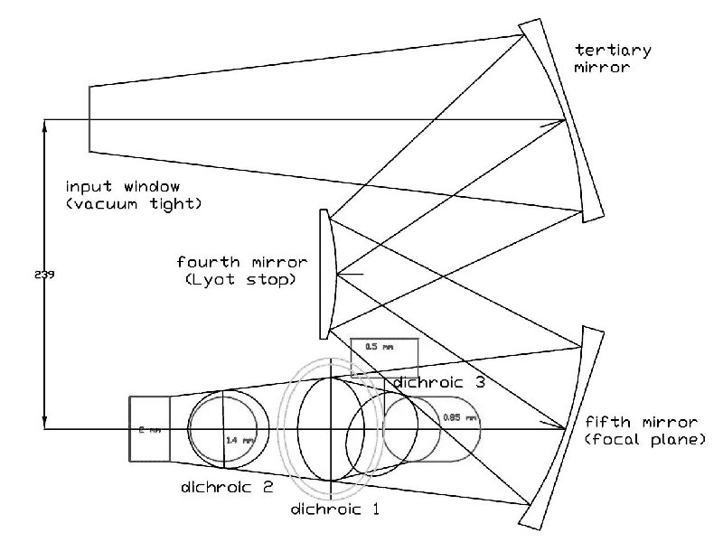
Figure 1 : Olimpo optical layout ( from [1])

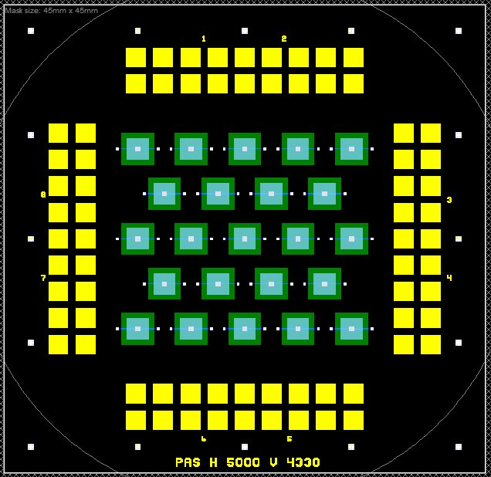
Figure 2 : 23 pixels matrix layout

External dimensions 45X45 mm with cutted edges for 2" wafer processing; membranes are 3X3 mm, Bi absorber are 2X2 mm and center-to-center distance is 5mm on a close packed array.

Background estimation

We will follow the approach used in [2] to evaluate the various contributions to the optical load on the bolometers.

We consider the following optical sources :

- Telescope T_{T} = 270 K, ε = 0.02
- Atmosphere T_{A} = 270 K, ε = 0.001 at z = 40 km
- Sky T_{S} = 2.7 K
- Cold Box T_{C} = 2 K ( cold Lyot stop )

Following the formulation used in [2], we separate the external contribution to the optical load. The internal one is the cold box radiation from the last optical filters.

The external brightness contribution takes into account the first three sources :

$$B_{\text{ext}}=ε_{T}⋅B_{ν}\left(T_{T}\right)+ε_{A}⋅\left(1−ε_{T}\right)⋅B_{ν}\left(T_{A}\right)+\left(1−ε_{A}\right)⋅\left(1−ε_{T}\right)⋅B_{ν}\left(T_{S}\right)$$

where B_{ν}(T) is the Planck function :

$$B_{ν}\left(T\right)=\frac{2{hν}^{3}}{c^{2}}⋅\frac{1}{\text{exp}\left(\frac{hν}{k_{B}T}\right)−1} \left({{W/{m^{2}}}/{\text{sr}}}/{\text{Hz}}\right)$$

The total load on the detector takes into account an imperfect optical transmission through the system and a detector responsive efficiency :

$$P_{\text{LOAD}}=AΩ⋅Δν⋅η_{o}⋅η_{d}⋅\left[η_{S}⋅B_{\text{ext}}+\left(1−η_{S}\right)⋅B_{{}_{ν}}\left(T_{C}\right)\right]$$

For the estimation, we used a global optical transmission η_{o} ~ 0.3 and a detector responsive efficiency η_{d} ~ 0.9. The spill over efficiency depends on the feedhorn mode operation. For single-moded horns ( 2.0 / 1.4 mm ), we used η_{S} ~ 0.7. For multi-moded operattion, we used η_{S} ~ 0.9 for ( λ = 0.85 / 0.50 mm ). We also considered a 30% bandwidth per channel : Δν = 0.30 ν_{C}.

The optical NEP is estimated by the classical shot noise limit : ${\text{NEP}}_{\text{photon}}≈\sqrt{2⋅P_{\text{LOAD}}⋅hν}$.

CHANNEL | Center Wavelength  ( mm ) | Throughput  ( 10⁻⁴ m².sr ) | #Modes  = AΩ/λ² | LOAD  ( pW ) | NEP_{photon}  ( W/Hz^{1/2} )
I | 2.0 | 0.04 | 1 | 1.5 | 1.7 10⁻¹⁷
II | 1.4 | 0.02 | 1 | 2.0 | 2.4 10⁻¹⁷
III | 0.85 | 0.02 | 2.7 | 10.6 | 7.1 10⁻¹⁷
IV | 0.50 | 0.02 | 7.8 | 50.8 | 2.0 10⁻¹⁶
Table 2 : Estimation of the optical loads at photon noise

Figure 3 : Comparison of the external sources contributions

Silicon Nitride Membranes Conductivity

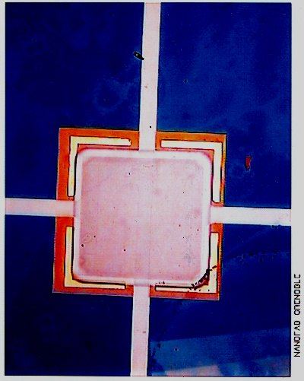

Figure 4 : Device for thermal conductance measurement ( LETI Silicon nitride membrane - 2 NbSi thin films are used to evaluate the self heating effect )

Si3N4 membrane size 1X1mm; e = 100nm
Niobium electrodes width 100 micron
Inter-electrodes distance 250 micron
Electrode length 600 micron
NbSi size 800X800 micron
NbSi thickness 100 nm
NbSi, niobium ratio 8,20%
Thermalization Au width 50 micron

Figure 5 : Silicon Nitride thermal conductance, comparison between various sources and techniques

We do observe a difference between the results obtained from a direct analysis made on NbSi thin films between the 'self heating' case and the external one ( heating is provided by the second film on previous devices ).

This effect is explained by the temperature gradient on the membrane. The thermometer temperature difference is about two time higher in the self heating case. The classical electrical method used to estimate the bolometer performances should take this effect into account.

We do not observe a significant influence of the membrane size. This is due to the particular heat flow geometry in the full membranes case ( approximately radial ). The only solution to reduce the thermal conductance is to use insulating Si₃N₄ micromachined beams.

As a conservative data for the bolometer performances predictions, we will use the following conductance law :

$$g=3\text{.}{\text{10}}^{−9}\left(\frac{T}{0\text{.}3K}\right) \left(W/K\right)$$

NbSi thin film optimization

The NbSi thin films resistivity and thermal properties have been extensively studied in the past by the CSNSM group [8].

A phenomenological model taking into account 1) a thermal decoupling between electrons and phonons and 2) a first order electrical field effect , accurately explains the electrical behaviour of thin films on a large temperature range ( 50mK ... 1K).

The resistivity model used is the following :

$$\begin{aligned}ρ\left(T_{\text{el}},E\right)=ρ_{0}⋅\text{exp}\left[{\left(\left(\frac{T_{0}}{T_{\text{el}}}\right)⋅\left(1−\frac{E}{E_{c}}\right)\right)}^{n}\right] \\ E_{C}=\frac{2⋅k_{B}⋅T_{\text{el}}}{q⋅L_{\text{LOC}}} \\ \frac{E^{2}}{ρ}=g_{e−\text{ph}}⋅\left(T_{\text{el}}^{5}−T_{\text{ph}}^{5}\right)\end{aligned}$$

L_{LOC} is a characteristic length for the variable range hopping process ( L_{LOC} ~ 10 nm ) and g_{e-ph} is the volumic thermal conductance between electrons and phonons (g_{e-ph} ~ 80 W/cm³/K⁵ ). 2D conduction effects have been investigated and is one cause of excess noise. We used film thickness > 300 nm in this design for which a low frequency excess noise < 3 Johnson noise could be obtained.

The parameters can be modified with the Nb_{x}Si_{1-x} alliage composition. Within the range x = 7.50 - 8.50 %, the correlation obtained is :

$$\begin{aligned}ρ_{0}=5\text{.}{\text{10}}^{−4} Ω\text{.}m \\ n=0\text{.}\text{65} \\ \frac{T_{0}}{1K}={\left(\text{26}−3⋅\frac{x}{1\text{\%}}\right)}^{2}\end{aligned}$$

For a given volume, there is an optimal polarisation of the film giving the minimum equivalent phonon temperature noise (NET - K/Hz^{1/2}) :

$$\begin{aligned}P∗(0\text{.}1−0\text{.}2)⋅g_{e−\text{ph}}⋅Ω⋅T_{\text{ph}}^{5} \\ E∗\left(0\text{.}\text{02}−0\text{.}\text{03}\right)⋅E_{c}\end{aligned}$$

In order to have an estimation of the optimal thermometer size, we suppose a 300 mK operation with a polarization at 100 pW. The characteristic electrical field Ec is ~ 5200 V/m. For a bolometer impedance of 10 MΩ under operation, we need a tension of ~ 32 mV and an interelectrode distance ( a ) of 320 μm. The minimum volume of the thermometer is 5.10⁻⁹ cm³, i.e an electrode length ( l ) of 160 μm for 100 nm thickness.

The thermometer design is done by simulation in order evaluate the influence on the bolometer performances. We have imposed a square film surface l = a and a thickness = 300 nm to keep a good margin for 2D conduction excess noise. For all calculation the thermometer impedance is 10 MΩ ( alloy composition is adpated ) and T = 300 mK ( phonons temperature ).

We first examine the thermometer sensitivity under polarization. For a polarization of 100 pW, the sensitivity and NET variation are marginal for a = l > 300 μm ( see Figure 6 ), which is consistent with the previous estimation. The thermometer noise figure NET is evaluated for an ideal Johnson noise ( Figure 7).
Figure 6 : Thermometer sensitivity A = dlnR/dlnT under polarization ( a = l = 200, 300, 400 μm; e = 300 nm ); R = 10 MΩ , T = 300 mK.

Figure 7 : Thermometer noise figure NET at Johnson noise ( a = l = 200, 300, 400 μm; e = 300 nm ) - R = 10 MΩ , T = 300 mK

Bolometer performances estimation

Electrical NEP estimation

The bolometer performances estimation takes into account :

1) a simplified estimation of phonon noise ( neglecting the temperature gradient in the membrane)
2) the contribution of the thermometer ( so-called Johnson noise )

$${\text{NEP}}^{2}=4k_{B}g_{\left(T\right)}T^{2}+g_{{\left(T\right)}^{2}}⋅{\left(\text{KJ}⋅\text{NET}\right)}^{2}$$

KJ is a coefficient to take into account an excess noise compared to the ideal Johnson noise. All the estimations are made with a conservative estimation KJ = 3 to take into account the measured excess noise of NbSi thin films at low frequency (0.1Hz).

The thermal link is :

$\begin{aligned}P_{\text{RAY}}+P_{J}=G⋅(T^{b}−T_{0}^{b}) \\ g_{\left(T\right)}=b⋅G⋅T^{b−1}\end{aligned}$

G = 5 nW/K²
b = 2
=> g_{( 300 mK )} = 3nW/K ( conservative estimation )

The estimated electrical NEP is 4.5 10⁻¹⁶ W/Hz ^{1/2} at a polarization of 90 pW (Figure 8). It is dominated by the thermometer noise. The last figure indicated the influence of the background on NEP (Figure 9).

Thermal inertia breakdown

The following table indicates the different contributions to the bolometer thermal inertia. We suppose a Bismuth absorber adapted for the 1.4 mm wavelength in a 1/4 λ cavity ( d = 1.5 λ ) with R_{C} = 377 Ω [7]. The theoretical thermal time constant is C/g ~ 0.7 - 2 ms ( for g = 1 - 3 nW/K ).

 | c  ( J/K/cm³ ) | V  ( cm³ ) | C  ( pJ/K )
Membrane Si₃N₄ ( 3 X 3 mm; e = 100 nm) | 18.10⁻⁸ | 900.10⁻⁹ | 0.16
Thermomètre (400 X 400 μm; e = 300 nm ) | 2.10⁻⁵ | 48.10⁻⁹ | 0.96
Absorber (2.1 X 2.1 mm; e = 100 nm ) | 2.10⁻⁶ | 441.10⁻⁹ | 0.88
Total | - | - | 2.0

Figure 8 : Bolometer electrical NEP estimation ( P = 0, R = 10 MΩ, T = 300 mK, KJ = 3 ); the NbSi film size is a = l = 300μm, e = 300 nm.
The figure shows the phonon noise and the thermometer contribution. The later dominates here due to the conservative excess noise hypothesis.

Figure 9 : Influence of the background ( P = 0 ; 100 pW; 200 pW - R = 10 MΩ, T = 300 mK, KJ = 3 )

Conclusions

Based on the current technique of full silicon membranes and NbSi thin film thermometers, we have estimated the expected performances of a 23 pixels matrix. At 300 mK a conservative estimation of the electrical NEP is 5.10⁻¹⁶ W/Hz ^{1/2} with a 100 pW background. It is dominated by the expected noise excess of the thermometer. The expected time constant is < 2 ms.

This estimation is compatible with previous measurements done on single pixel. Nevertheless, we do expect a significative improvement from the modified size of the NbSi thermometers ( thickness was only 100 nm and interelectrodes distance 200 μm ). Also, margin has been taken on the membrane conductance for the calculation.

Without micromachined silicon nitride beams, the only potential application on the Olimpo experiment is the channel IV ( 0.5 mm ).

References

- S.Masi et al, OLIMPO : a few arcmin resolution survey of the sky at mm and sub-mm wavelengths, Mem. S.A.It. Vol 74, 96 (2003)
- M.Griffin et al, The Relative Performance of Filled and Feedhorn-Coupled Focal Plane Architecture, astroph-0205264.
- Leivo, Pekola, APL,72,11 (1998)
- Spider Web, personal communication from J.J.Bock, 1997.
- S.Yates, CRTBT, 19/4/2004.
- Camus et al, Low temperature NbSi thin film thermometers on silicon nitride membranes for bolometer application, NIMA 444 (2000) 419-422.
- J.Glenn et al, Numerical optimization of integrating cavities for diffraction-limited millimeter-wave bolometer, Appl.Opt. 41, 136-142 (2002)
- S.Marnieros, PRL 84 (11), 13 March 2000

